**HAWAII AGRICULTURE FOOD & PRODUCTS**

**Create a web/mobile app where people can search for companies doing business in Hawaii offering Hawaii food & products. Must be 100% grown or value-added products with at least 50% of inputs from Hawaii**.

**GOAL: Grow Hawaii’s agriculture food and products industry by connecting local, national and international buyers to local companies.**

**FEATURES ENVISIONED**

**VENDOR**

* Ability to enter/update company information
* Ability to enter/update product information being sold (include *HS Code if able to sell internationally)
* Ability to securely access/update only their own information.
* Ability to recover/reset password securely.

**BUYERS**

* Ability for local, national and international buyers to search database for Hawaii agriculture food & products and contact seller directly.
* Ability to generate email request to search result companies.
* Ability for multiple field searches (i.e. Certified Organic, papaya, sold on Kauai)
* Ability to search by product description or Harmonized System Code (for international buyers).

**\* Harmonized System Code (HS Code) – 10 digit code**

* The Harmonized Commodity Description and Coding System, also known as the Harmonized System (HS) of tariff nomenclature is an internationally standardized system of names and numbers to classify traded products.

Project Manager: Sharon Hurd Phone: 973-9465 Email: [Sharon.K.Hurd@hawaii.gov](mailto:Sharon.K.Hurd@hawaii.gov)  
Project Member: Helene Okamura Phone: 973-9490 Email: [Helene.M.Okamura@hawaii.gov](mailto:Helene.M.Okamura@hawaii.gov)

**WORKFLOW**

**VENDOR’S WORKFLOW**

* Run through a brief online questionnaire to see if they meet qualification (Must be 100% grown or value added products with at least 50% of inputs from Hawaii, have a valid Hawaii Business Registration Number).
* If vendor meets qualification, then they can proceed to enter company information, setup logon and password, enter product information.
* Create confirmation page for vendor to attest all information entered is “True”
* Entry submitted to [HDOA.MD@hawaii.gov](mailto:HDOA.MD@hawaii.gov) for verification. When approved, record uploaded to website.
* Sample screen layout

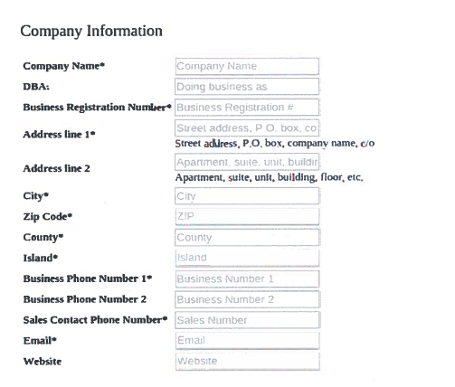

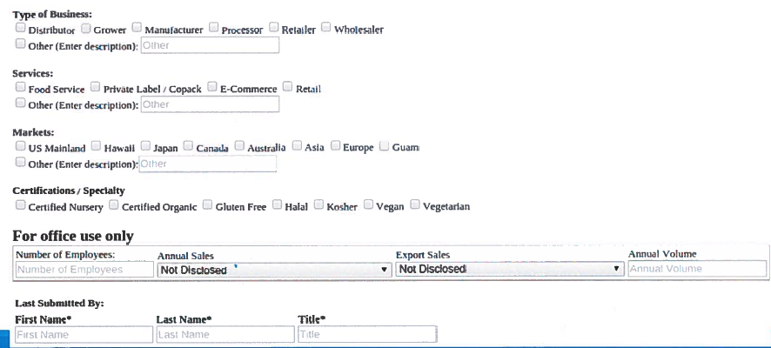

* Additional fields:
  + Where products are locally sold (i.e. Foodland, KCC Farmer’s Market, KTA, etc.)
  + Seller’s logon and password.

**PRODUCTS INFORMATION**

* Sample layout (needs to be user-friendly)
* Accommodate way for user to add additional products as demand dictates.

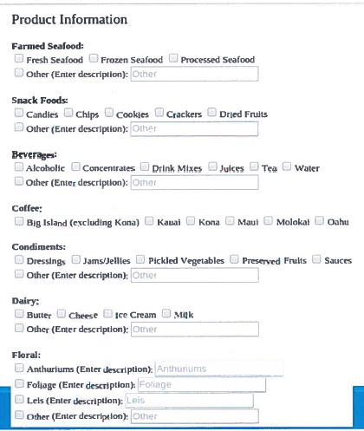

* Additional fields:
  + HS Codes (for international business) – single field with ability to add multiple HS codes separated by commas – allow for minimum 20 codes). For test purposes, you can use random 10-digit codes or look up codes at <http://www.foreign-trade.com/reference/hscode.htm>

**BUYER’S WORKFLOW**

* Buyer able to search for products in a user-friendly interface.

Sample search screen:

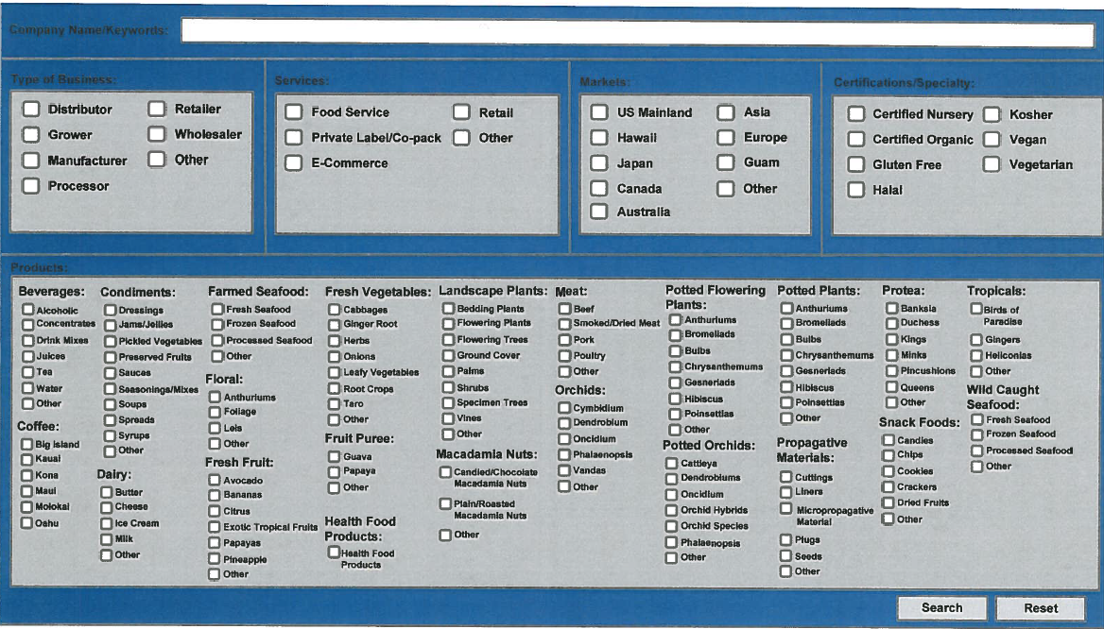

* Search results can be displayed and downloaded in pdf format (with email and web links)
* Additional search screen or field to search by HS Code for international buyers.
* Easy way for buyer to generate email request to vendor generated from search results (should identify buyer’s name and/or company, product, destination, etc.)

**DATA AVAILABILITY**

Data from the previous Hawaii Agriculture Food and Products database available at ETS hub in .csv format or you can create your own data if existing data does not match your design.